Al Rawnak Shaﬁn

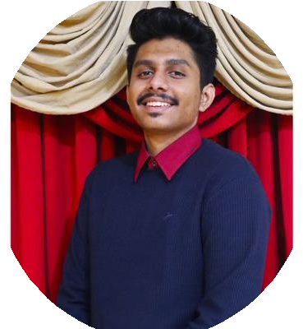

* [rawnokshaﬁn2000.ars@gmail.com](mailto:rawnokshafin2000.ars@gmail.com)

+8801752075288

Mohammadia Housing Limited, Mohammadpur, Dhaka, Bangladesh

Intern

Reliable Intern studying **Computer Science and Engineering** at **Independent University of Bangladesh** , a very well known private university of our country seeking an internship opportunity to expand skills and gain valuable real-world experience. I am also organized and dependable candidate with good multitasking ability. I'm willing to give my best as a **Junior Developer** at my dream place to work. Also I will try my best to maintain part-time position that can execute professional challenges as a programmer at your well known farm.

# EDUCATION

## Computer Science and Engineering

### Independent University Dhaka

*05/2020 - Present*, ***CGPA 3.51***

# SKILLS

Multitasking      Flexible

**>>**CSE 203 (Data

Structure) made full workable calendar with set able reminders. Debugged many codes . Finished course with excellent grade.

**>>**Continuing education in MIS in computer science as a MINOR subject.

**>>**Completed CSC 101( C++ programming language) with A- grade .

**>>**Took part in ACM ICPC.

Responsible      Adaptability      Good listener      Team Builder     

Patience

## Higher Secondary Certiﬁcate (HSC)

### Ideal College Dhanmondi

*01/2018 - 04/2020*, ***GPA 3.68***

**>>**Science

## Secondary School Certiﬁcate (SSC)

### Dhanmondi Govt. Boys High School

*02/2015 - 12/2017*, ***GPA 4.78***

**>>**Science

**REFERENCES**

Mr. Sayem Sihab Mr. Sheikh Bin Enam

Web Developer Software Engineer

Leadsoft Bangladesh Tecnotree Corp.

Dhanmondi,Dhaka-1209 Cell +35841725828

Cell- 01733249699

Communication     

**COMPUTER & PROGRAMMING SKILLS:**

MS Office      C++ programming language      C programming language     

# PROJECTS

>Made a calendar with reminders using C++ (07/2021 )

**>>**Scored 5/5 (Including viva).

>Made calculator using C++ and debugged many codes at professional sites.

# LANGUAGES

* English *Full Professional Proﬁciency*
* Bangla *Native Proﬁciency*